PERFORMANCE ANALYSIS OF FM SYSTEM UNDER GAUSSIAN WHITE NOISE USING MATLAB
Analog and Digital Communication — Experiment 10
Date of Experiment | 12/10/2026
Performed By | Lokesh A
Register Number | 192512293
1. Aim
To generate a frequency-modulated (FM) signal in MATLAB, introduce additive Gaussian white noise, and observe the effect of noise on the received FM waveform.
2. MATLAB Program
clc;
clear;
close all;
% Parameters
fs = 100000;
t = 0:1/fs:0.02;
fm = 500; % Message frequency
fc = 5000; % Carrier frequency
kf = 100; % Frequency sensitivity
% Message Signal
m = cos(2*pi*fm*t);
c = cos(2*pi*fc*t);
% FM Modulation
fm_sig = cos(2*pi*fc*t + 2*pi*kf*cumsum(m)/fs);
% Add Gaussian White Noise
noisy = awgn(fm_sig,10,'measured'); % 10 dB SNR
% Display
figure;
subplot(4,1,1)
plot(t,m)
title('Message Signal')
grid on
subplot(4,1,2)
plot(t,m)
title('Carrier Signal')
grid on
subplot(4,1,3)
plot(t,fm_sig)
title('FM Signal')
grid on
subplot(4,1,4)
plot(t,noisy)
title('FM Signal with Gaussian White Noise')
grid on
3. Output
The plots display the message signal, the signal labelled as the carrier in the supplied program, the FM signal, and the FM signal after adding Gaussian white noise. The noisy waveform shows random amplitude variations caused by the simulated noise.
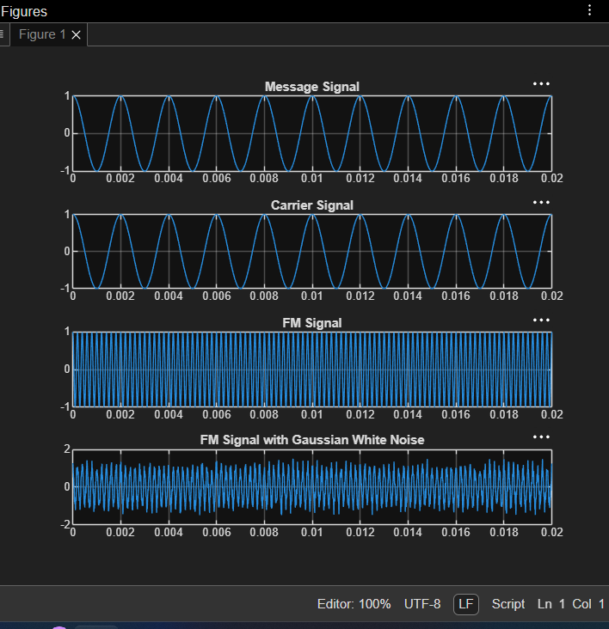
Figure 1. MATLAB output showing the message, carrier-labelled waveform, FM signal and noisy FM signal.
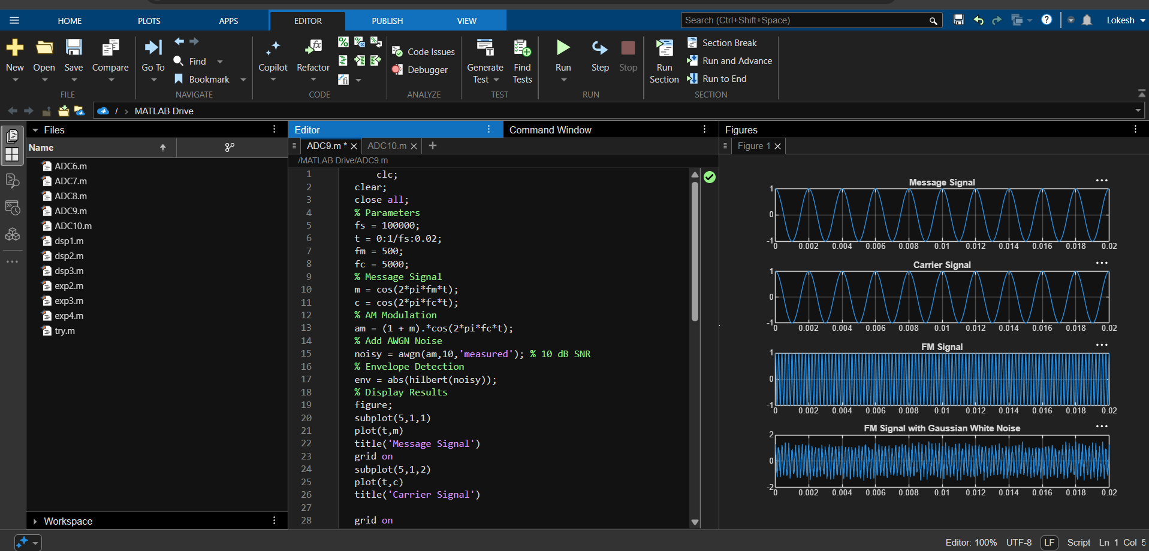
Figure 2. MATLAB editor and graphical output for FM performance under Gaussian white noise.
4. Simulation Parameters
Parameter | Value
Sampling frequency (fs) | 100,000 Hz
Message frequency (fm) | 500 Hz
Carrier frequency (fc) | 5,000 Hz
Frequency sensitivity (kf) | 100
Simulation duration | 0.02 s
Noise model | Additive Gaussian White Noise
Signal-to-noise ratio (SNR) | 10 dB
5. Applications
- Evaluating FM signal behaviour in noisy communication channels.
- Studying noise effects in FM receivers and communication-system simulations.
- Testing and demonstrating the role of signal-to-noise ratio in received-signal quality.
- Educational analysis of angle modulation and channel noise in Analog and Digital Communication.
6. Alignment with Analog and Digital Communication
This experiment demonstrates frequency modulation and the effect of additive white Gaussian noise (AWGN) on a modulated signal. MATLAB is used to construct the FM waveform and compare it with the noisy waveform, linking modulation theory with channel impairment.
ADC Concept | Implementation | Observed Output
Message signal | m = cos(2*pi*fm*t) | Message Signal plot
Carrier expression | c = cos(2*pi*fc*t) | Program defines carrier; plotting line currently uses m
FM generation | fm_sig = cos(2*pi*fc*t + 2*pi*kf*cumsum(m)/fs) | FM Signal plot
Noisy channel | awgn(fm_sig,10,'measured') | FM Signal with Gaussian White Noise plot
SNR | 10 dB | Noise level set by AWGN function
7. Justification
- The message signal provides the low-frequency information used to vary the instantaneous phase of the carrier in FM.
- The FM waveform demonstrates angle modulation with a constant nominal amplitude.
- AWGN is added at a specified 10 dB SNR to model random channel noise.
- Comparing the FM and noisy FM plots visually demonstrates the effect of noise on the received waveform.
- The supplied code plots m in the second subplot despite labelling it 'Carrier Signal'; the document preserves the given program rather than silently changing it.
8. Conclusion
The FM signal was generated using MATLAB and additive Gaussian white noise was introduced at an SNR of 10 dB. The message, carrier-labelled waveform, FM waveform and noisy FM waveform were plotted. The comparison illustrates the influence of channel noise on an FM signal.
DONE BY
Lokesh A
Register Number: 192512293
B.E. Electronics and Communication Engineering (ECE)

